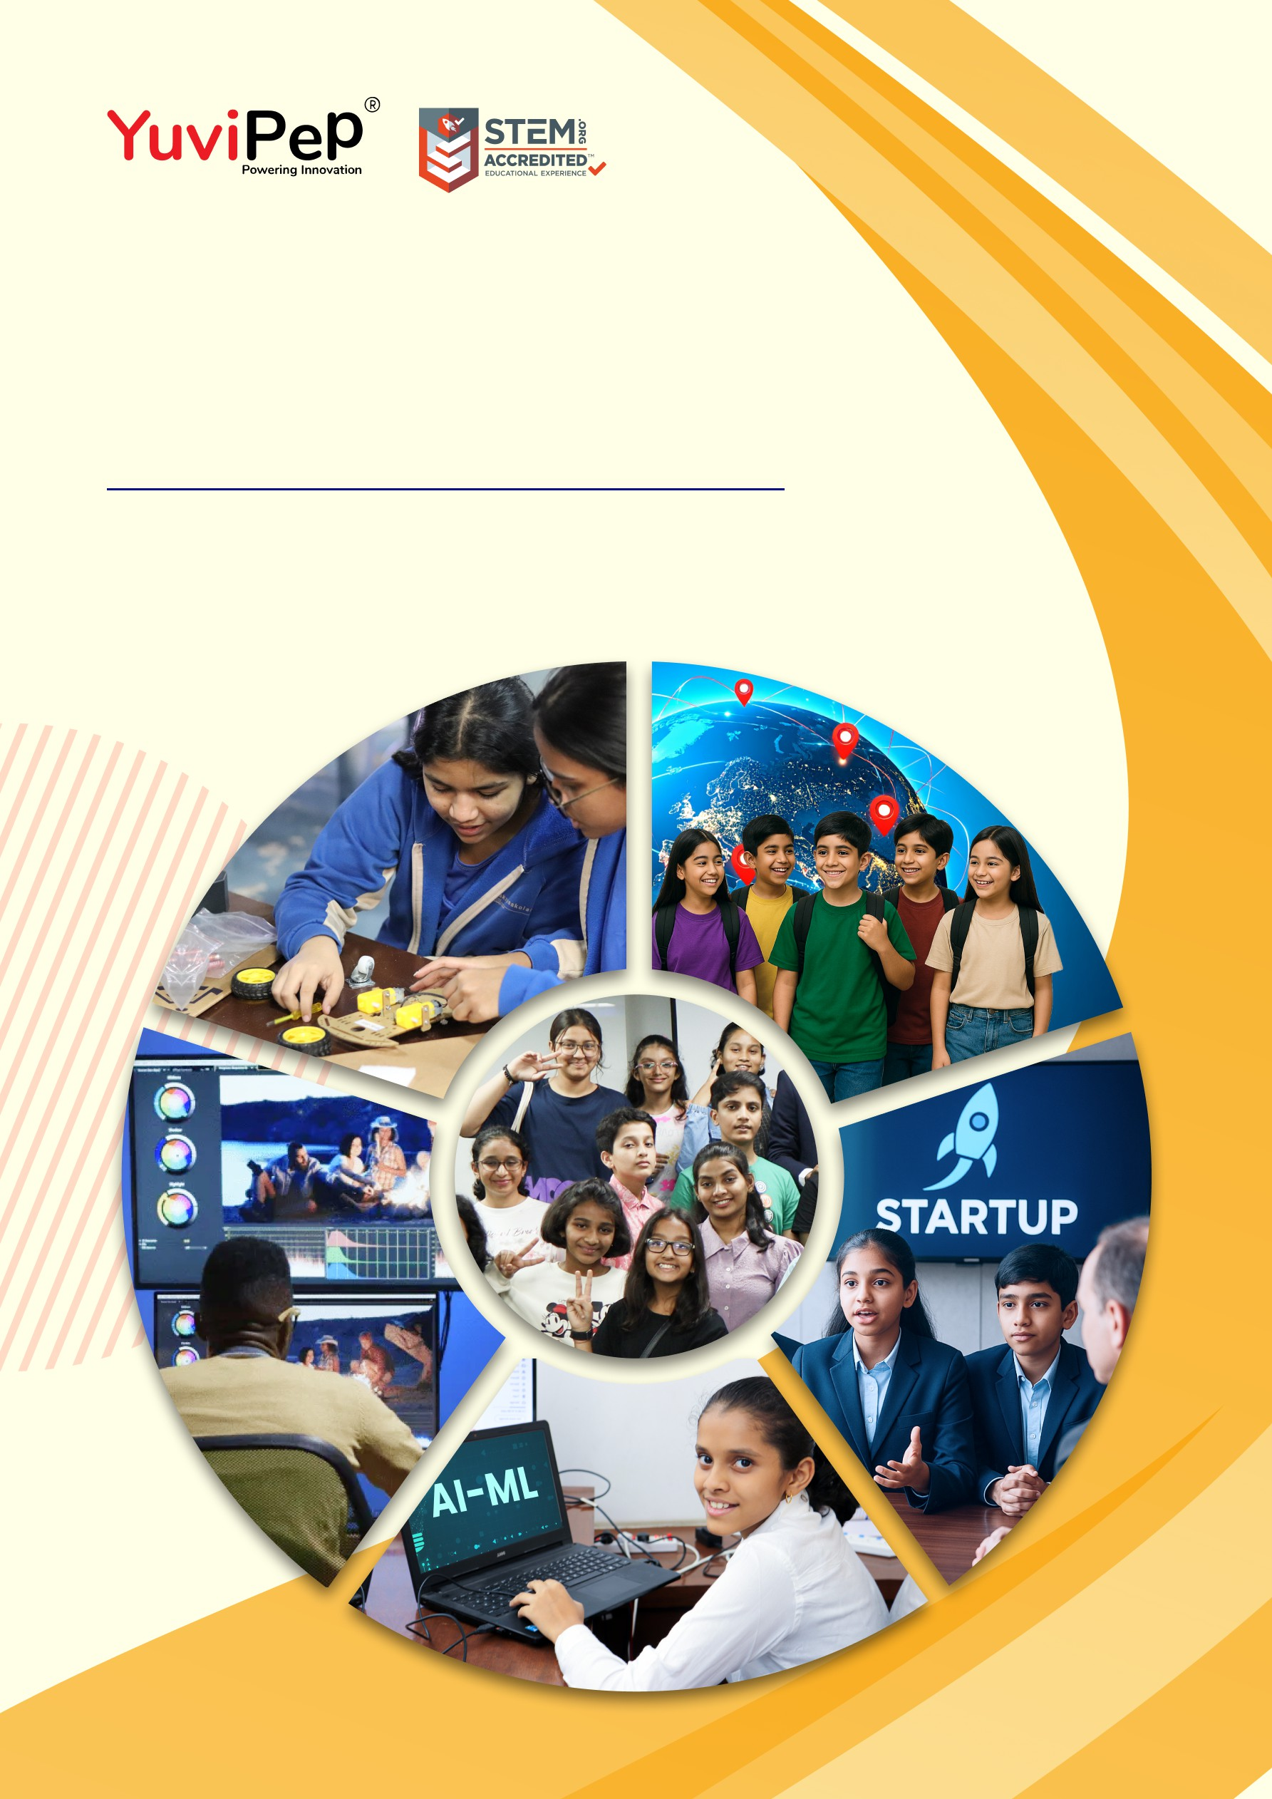

Proposal For

Essential Lab

School Name

Document Version: 1.0
- 1 -
Copyright 2026 YuviPep© All Rights Reserved School Name

About YuviPep’s Innovation Ecosystem

Igniting Innovation, Empowering the Future
YuviPep is a global learning ecosystem that empowers students through experiential education in technology, innovation, design thinking, AI, internships and entrepreneurship. It prepares them to become future-ready creators and problem-solvers.
Our ecosystem is designed to inspire ingenuity and an innovative mindset from an early age. Through engaging programmes such as Academics Beyond Classroom (ABC), Innovation Base Course (IBC), AI & ML, Young Creators Media World, GEN-i Internships and more, we support students from grades 1 to 12 on a journey of self-discovery and skill development. All programmes are aligned with the National Education Policy and the Skill Development Mission and are STEM.org accredited.
YuviPep’s Young Founders Network connects students with industry experts, global platforms, and even early-stage funding to advance their ideas. With partnerships across 200+ institutions and 100+ organisations, we are opening doors to the future.
Learning at YuviPep is hands-on and purposeful. Whether exploring ideas, collaborating on projects, building models, or presenting innovations on global platforms, students gain experiences that last a lifetime.

Our Mission
To build a global educational ecosystem that empowers learners through exploration, innovation and real-world experiences.
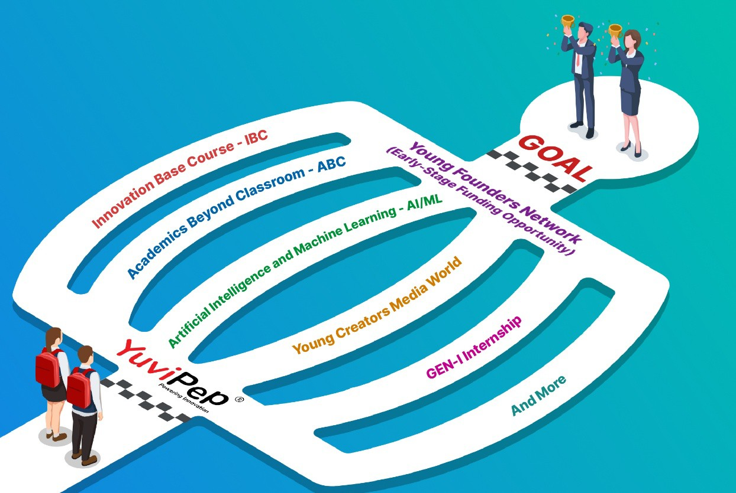

- 1 -

Copyright 2026 YuviPep© All Rights Reserved School Name

YuviPep Essential Lab
YuviPep will transform an existing workshop area or a dedicated classroom at School Name into an Essential Lab. The lab will be fully equipped with the tools and equipment required to run the IBC programme.
As part of this setup, the school will provide a suitable space, seating, tables, basic interior furnishings, and reliable internet connectivity.
The Essential Lab will provide students with hands-on exposure to eight core pillars: Practical Science, Design Thinking, Coding, Mechatronics, Automation, Artificial Intelligence, Internet of Things, and Robotics. By transforming classrooms into active spaces for experimentation, the lab will nurture creativity, strengthen problem-solving abilities, and build future-ready skills.
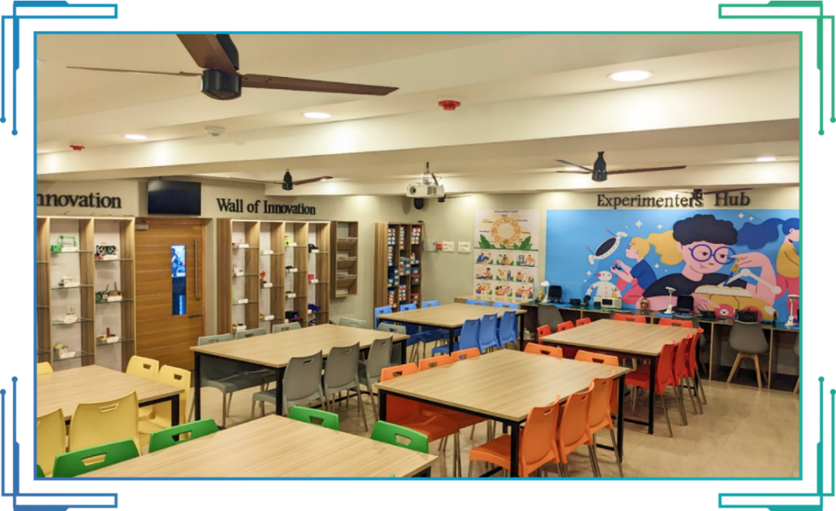
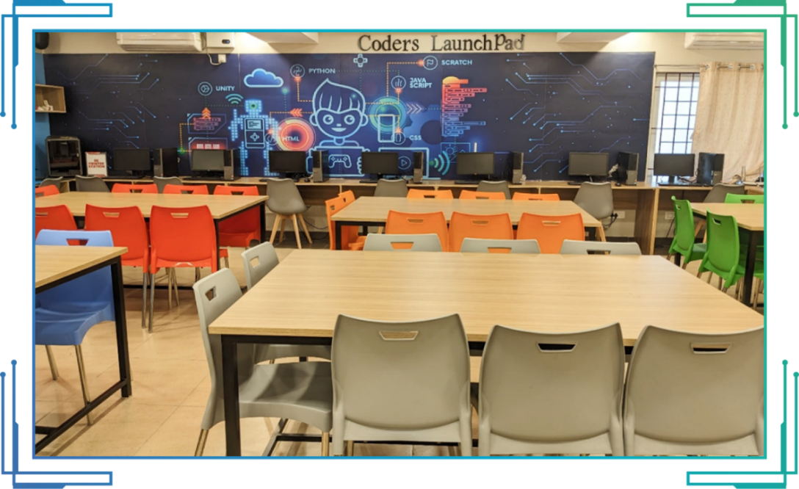

Note: The photos shown below are for reference only. The actual design, look and feel of the lab will depend on the space and interiors provided by the school.

- 2 -

Copyright 2026 YuviPep© All Rights Reserved School Name

Essential Lab Details

Deliverables | Essential Labs | Quantities
Hands-on robotics prototypes (Grades 1–10) | Included | 80+ components
Hands-on practical science prototypes (Grades 1–10) | Included | 300+ components
Hands-on design thinking kits (Grades 1–10) | Included | 350+ components
Raw prototyping kits (Grades 1–10) | Included | 70+ components
Animatronics essentials | Included | 1 unit
Wall posters | Included | 1 unit
Pegboard with mechanical tools | Included | 1 board with 50+ tools
Soldering station | Included | 1 unit
Basic requirements for STEM integration | Included | Miscellaneous
Building blocks | Included | 1000+ blocks
Aeromodelling and technology | Included | 200+ units
Hands-on agriculture and sustainability prototypes (Grades 1–10) | Included | Total components= 3500+

Investment Overview

Pricing Structure

Particulars | Programme Investment
Essential Labs | Rs. 10,00,000/- Net (Including GST)  Note: The price applies to both TCIS branches combined.
Note: The exclusive price applies only to School Name.

Payment Terms and Options

Advance Payment | An advance payment is collected upon signing the Memorandum of Understanding (MoU).
Payment Options | For your convenience, payments can be made through NEFT, cheques, Credit cards, or Debit cards.

Disclaimer: This document and its contents are the exclusive property of YuviPep Education Private Limited and are strictly confidential. No part of it may be disclosed, copied, reproduced, distributed, or used without prior written consent from YuviPep Education Private Limited. Unauthorised use or disclosure may lead to legal action.



Contact Details
+91 93640 05019
info@yuvipep.com www.yuvipep.com

YuviPep Education Pvt Ltd,
Neil Rao Towers, Plot #117, Rd Number #3, EPIP Phase I, Whitefield,
Bengaluru, India

